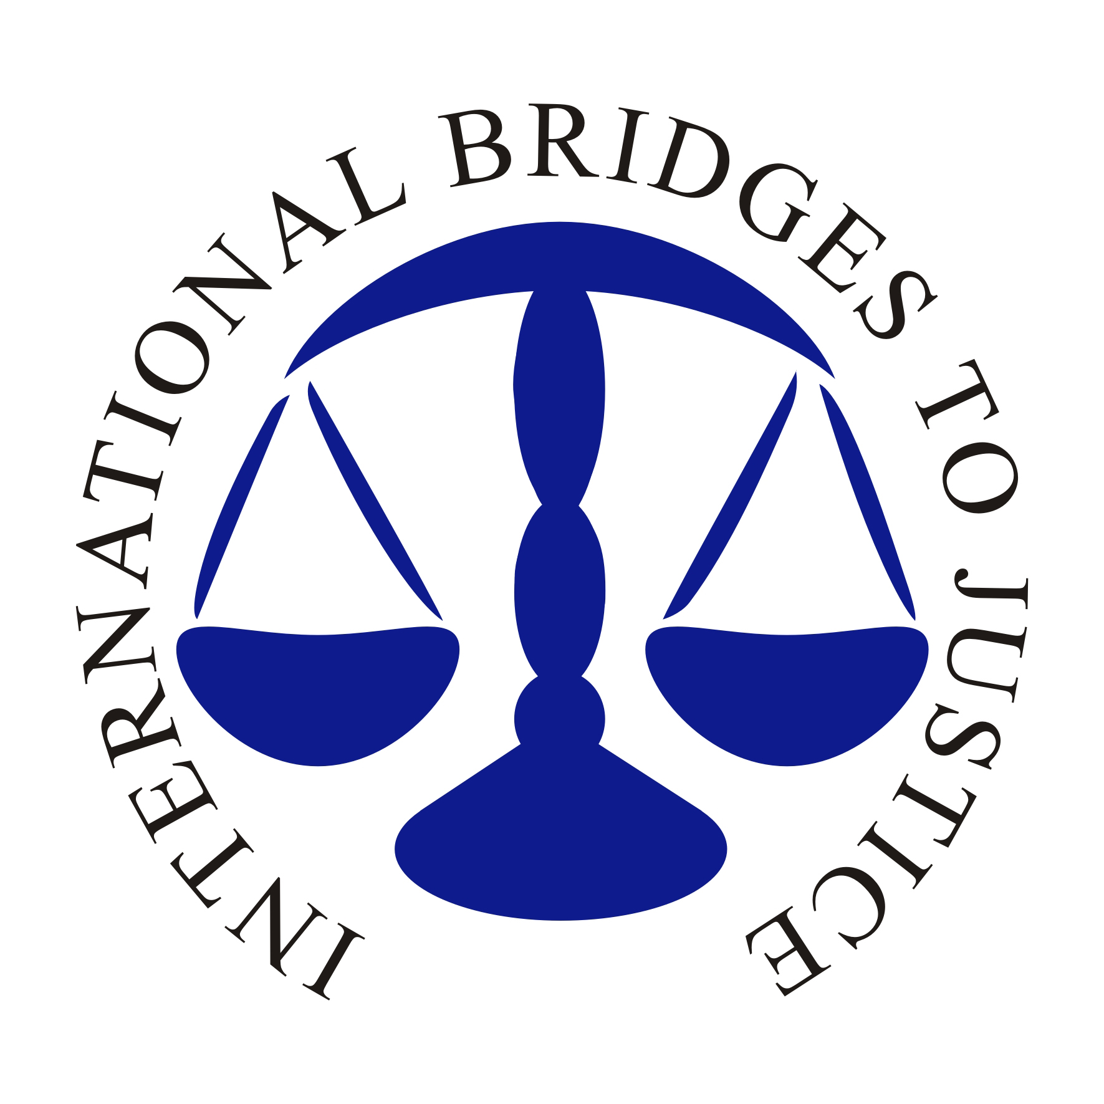
International Bridges to Justice
Promotion and Protection of Legal Rights in Africa
Progress Report: January – July 2007

In November 2006, a delegation from the International Bridges to Justice honored invitations to visit Burundi, Rwanda and Zimbabwe and met with senior government officials, bar associations, individual lawyers and civil society organizations to discuss the prospect of initiating a pilot Africa project in those countries. The IBJ delegation also visited prisons, courts and legal aid centers. In all three countries, IBJ conducted preliminary legal and technical needs assessments and established essential working partnerships with state institutions, bar associations and civil society organizations. Following close to a year of rigorous planning, research and networking, IBJ has now begun work on promoting implementation of just laws at the domestic level. As the program unfolds, IBJ hopes to help create fairer and more effective criminal justice systems that protect the rights of all, especially the poorest and most vulnerable members of society.

Burundi

In Burundi, IBJ signed a Memorandum of Understanding with the Bar Association of Burundi, and established a strong partnership with the Association for the Protection of Human Rights and Detained Persons (APRODH). Together with APRODH and the Bar Association, IBJ has produced 10,000 ‘Know Your Rights’ posters that are being distributed in prisons, police stations, local government offices and other public centers in all of Burundi’s 17 provinces. The purpose of the poster campaign is to educate ordinary citizens, detainees and law enforcement agents on the right of accused persons to freedom from torture, right to legal counsel and right to a fair trial.
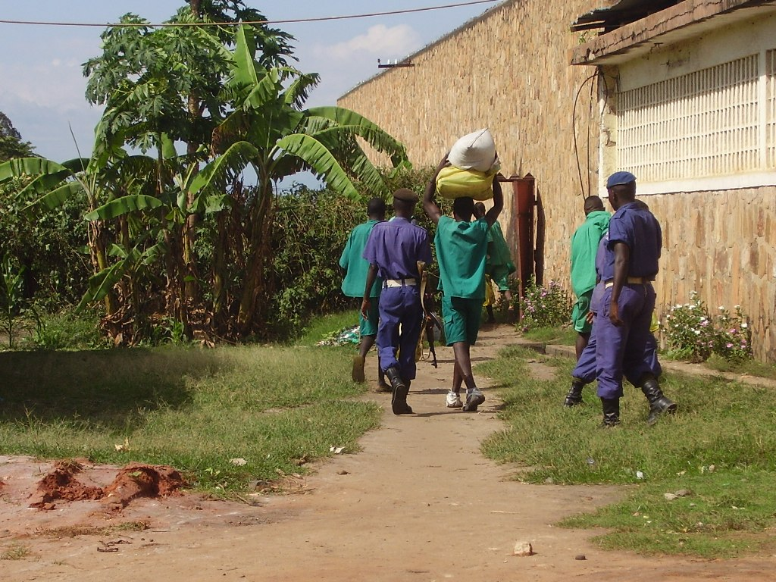

Fig 1: Prison Guards supervise prisoners working at Mpimba Central Prison, Bujumbura.

During the 2006 assessment visit, IBJ visited Mpimba Central Prison in Bujumbura and met with government officials in charge of prisons who all agreed that there is an urgent need to strengthen Burundi’s justice system, especially in the aftermath of the civil war. Profound institutional weaknesses, lack of trained personnel and resources are hampering the effective implementation of new laws and access to justice for millions of people. Burundi’s 9 million strong population relies on the services of only 90 qualified lawyers, all based in the capital, Bujumbura. Of the approximately 8,000 prisoners nationwide, 62% are pretrial detainees who are unable to afford legal representation. In addition, without a juvenile justice system, over 400 child detainees at any given time are held in the same overcrowded communal cells as convicted adult criminals, which often leaves them vulnerable to abuse.

IBJ has begun official registration with the Ministry of Foreign Affairs and International Cooperation and hired Fulgence Ndagijimana to work as IBJ’s Local Representative. IBJ is currently interviewing local criminal defense lawyers who will lead its full range of programming, including a comprehensive capacity building program for criminal defense lawyers under the auspices of its new Global Defender Support program.

Rwanda

In Rwanda, IBJ has established strong working partnerships with the Ministry of Justice, the Bar Association of Kigali and the Prosecutor General’s Office. With the support of London law firm, Matrix Chambers, IBJ has joined forces with the Ministry of Justice, Bar Association of Kigali and the Belgian Technical Cooperation to produce ‘Know Your Rights’ posters that will be distributed in prisons, police stations, universities, local government offices and other public centers. The posters are done in Kinyarwanda, Rwanda’s national language, to ensure that the message is understood by the greatest number of citizens possible. IBJ’s main aim is to educate ordinary citizens, detainees and law enforcement agents on the right of accused persons to freedom from torture, right to legal counsel and right to a fair trial.
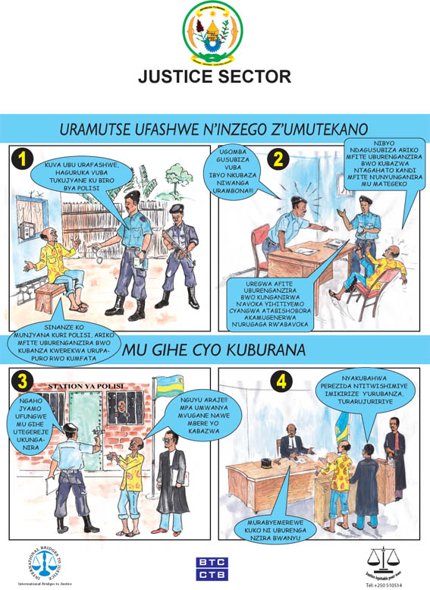

IBJ has also deployed a top US legal aid expert to help Rwanda’s Ministry of Justice develop a comprehensive and sustainable national legal aid policy and operational framework.

Fig 2: IBJ Rwanda ‘Know Your Rights’ Poster

Rwanda’s Justice Sector is launching the National Institute of Legal Practice and Development that will soon start an intensive training program for the country’s legal profession. However, this initiative alone will not be adequate to address the huge gap in the implementation of criminal justice in the country, especially given the strain brought on the legal system by thousands of outstanding genocide cases. Rwanda has only approximately 200 lawyers and 260 judges in the entire country. In addition, the poverty of most of those accused of crimes makes it difficult for legal representation to be obtained widely. Only an estimated ten percent of criminal defendants are able to afford a private lawyer. IBJ, therefore, remains committed to mobilizing international support to help develop the skills of Rwanda’s criminal defense lawyers and strengthening the country’s justice system in general.

Zimbabwe

International Bridges to Justice attended the Law Society of Zimbabwe 2006 Summer School and met with the president of the Law Society, executive councilors and several local lawyers. IBJ also held discussions with various stakeholders in Zimbabwe’s justice system, including the Minister of Justice, the Judge President of the High Court, the state-funded Legal Aid Directorate, the Police Forensic Science Unit and the Legal Resources Foundation. IBJ agreed on the form of a Memorandum of Understanding with the Ministry of Justice’s Legal Aid Directorate that will allow it to carry out its activities in Zimbabwe and help strengthen the rule of law and supporting the implementation of just criminal laws in the country. IBJ also established solid working partnerships with the Law Society of Zimbabwe and the Legal Resources Foundation.

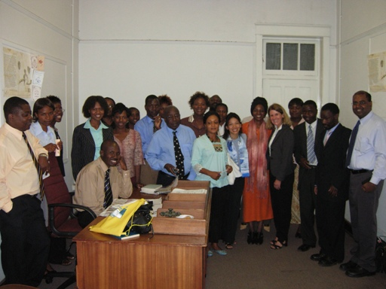

Fig 3: Legal Aid Directorate, Harare, Zimbabwe. IBJ staff met the fifteen young lawyers who have the onerous task of providing free legal services to millions of poor Zimbabweans.

After conducting a preliminary legal needs assessment, IBJ embarked on the production and updating of Legal Skills Development Toolkits for Defense Lawyers, Prosecutors, Magistrates, and Police in Zimbabwe. IBJ recognizes that the great majority of Zimbabwe’s lawyers, magistrates and police have not been trained to adapt to recent landmark changes to the country’s criminal laws and procedure. Most of the existing practical guides for lawyers and other criminal justice actors are outdated. IBJ is, therefore, working to ensure that the updated legal toolkits will help to provide practical and readily available guides for these courageous defenders. This project is being implemented in partnership with the Law Society of Zimbabwe and the Legal Resources Foundation of Zimbabwe.

In the near future, IBJ looks to appoint committed local criminal defense lawyers to work as IBJ Fellows and help provide effective and much needed legal representation for the many pretrial detainees and indigent Zimbabweans.

Submitted: Marlon Zakeyo
IBJ Africa Program Fellow
mzakeyo@ibj.org

August 3, 2007

